HRP Remora

The HRP Remora is included with Triton in the ExampleRemoras folder in the main Triton directory. This Remora can be enabled to process and inspect raw (HRP) data.

Converting multiple HRP files to XWAVs
Currently in development
Converting an HRP file to an XWAV
The program will prompt you to choose an *.hrp file and a *.hdr file to process, as well as a directory to output the resulting xwavs to.

Header files
Header files are needed to add the necessary metadata to the finished xwav files. Included in this Remora is ‘Example.hdr’, which specifies what the format of a header file corresponding to an HRP file should look like. Mind the character length specifications for the experiment name, site name, and instrument ID. If these do not have the correct number of characters, the program may not behave as expected.

Reading an HRP file header
The program will prompt you to choose an *.hrp file. After selecting, the header information can be viewed in the message window.

Getting HRP file directory list
The program will prompt you to choose an *.hrp file. After selecting, the hrp directory list information can be viewed in the command window as seen below.
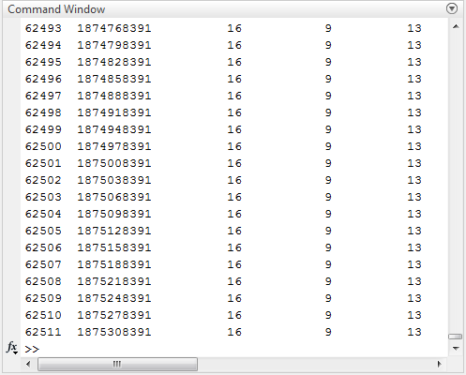

Getting directory list times
A prompt will appear asking whether you’d like to analyze a single file (0) or a directory of files (1). The program will then prompt you to choose an *.hrp file, and enter a sampling rate, recording interval, recording duration, and number of channels associated with the file. The hrp directory list times can then be viewed in the Triton message window.

Plotting sector times
You will be prompted to choose a *.hrp file. A dialog box will pop up asking you if you’d like your graphs to display, along with the first raw file number, the number of raw files to process, and the number of channels. After filling in your options and pressing ‘OK’, your plots will be created.

